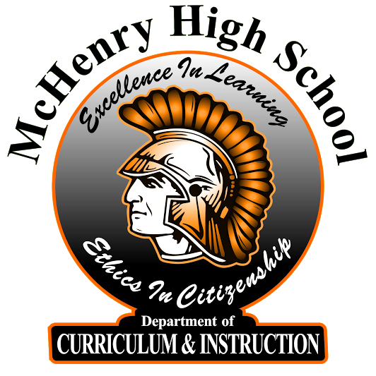
MCHS End-of-Course Student Survey

Teachers at MCHS are constantly looking to grow in the area of course quality, delivery of instruction, and service to students. Student feedback is very important in this process. Please provide honest and fair feedback so that your instructor can goal set for future growth in these areas. This feedback is anonymous and for the instructor only. Thank you for your feedback!

 | 3 | 2 | 1 | 0
Indicator | Strongly Agree | Agree | Disagree | Strongly Disagree
My teacher in this class makes me feel like he/she really cares about me.
My teacher starts class everyday promptly and with an igniting activity.
My classmates behave the way my teacher wants them to.*
Our class stays busy and does not waste time.*
Students in this class treat the teacher with respect.*
My teacher tells us what our daily learning targets are and helps us understand why they are relevant.
In this class, we learn to correct our mistakes.*
My teacher knows when the class understands, and when we do not.
In this class, we learn a lot almost everyday.*
My teacher does not let students give up when the work gets hard.
In this class, the homework assigned helps me learn and improve.
My teacher makes lessons interesting.
My teacher often checks to make sure we understand what he/she is teaching us.
The feedback I get on my work in this class helps me understand how to improve.
My teacher takes the time to summarize what we learn each day.

This survey is based on research produced from the Measures of Effective Teaching (MET) project.

